c/o American Fisheries Society November 21, 2016
425 Barlow Place, Suite 110
Bethesda, MD 20814
301-897-8616

Dear President-Elect Trump,

The Consortium of Aquatic Scientific Societies (CASS) is writing to offer our best wishes and assistance as you begin your Presidency. We understand that your transition team and future administration will have many important decisions to make regarding our Nation’s aquatic resources, and CASS is ready to provide the requisite expertise to help your administration address those pressing concerns.

CASS is comprised of six professional societies representing diverse knowledge of the aquatic science realm. CASS members include the: American Fisheries Society; Association for the Sciences of Limnology and Oceanography; Coastal and Estuarine Research Federation; Phycological Society of America; Society for Freshwater Science; and Society of Wetland Scientists. Our collective membership totals almost 20,000 individuals that span the private sector, academia and various tribal, state, and federal agencies. The CASS organizations represent professionals who combine deep subject-matter expertise, a commitment to independent objectivity, and the critical review of environmental information, along with a passion for the natural places and resources that form the foundation of American greatness. Many of our members are dedicated anglers, hunters, and outdoor enthusiasts.

When deliberating over issues pertaining to our natural environment we urge you to consult with CASS. Our member societies can provide unbiased information through meetings, briefings, or position papers on important issues including but not limited to:

- Ensuring the Nation’s water is clean and in good supply
- Managing sustainable fish populations for food and recreation
- Building resilient systems for our natural resources and our human communities
- Repairing the fragmentation of our Nation’s rivers and streams
- Improving and protecting the habitat of our Nation’s aquatic resources
- Maintaining the biodiversity of aquatic systems by managing aquatic invasive species, protected species, and other species of concern
- Developing sustainable aquaculture to secure America’s protein demands and support recreational opportunities
- Protecting America’s conservation heritage and the enormous economic and cultural benefits derived from outdoor recreation

Input from CASS leaders and members will help to ensure that your choices secure the cultural heritage and economic prosperity of all Americans. We look forward to addressing your inquiries in the weeks to come.

Respectfully,

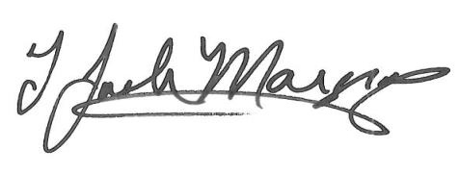
Joe Margraf
President, American Fisheries Society

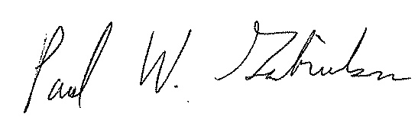
Paul Gabrielson
President, Phycological Society of America

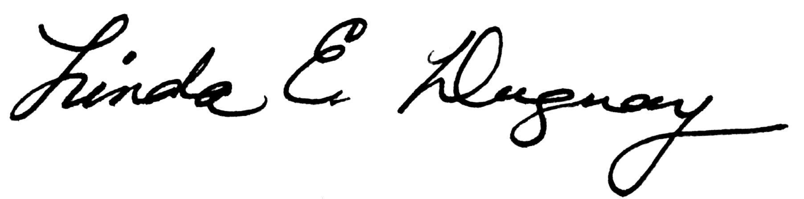
Linda Duguay
President, Association for the Sciences of Limnology and Oceanography
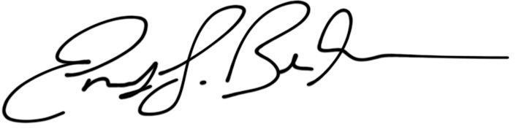
Emily Bernhardt
President, Society for Freshwater Science

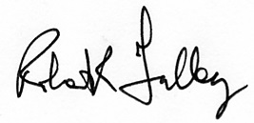
Robert R. Twilley
President, Coastal and Estuarine Research Federation

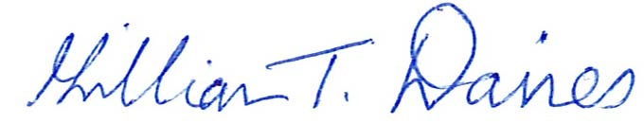
Gillian Davies
President, Society of Wetland Scientists

